ISLAMIC UNIVERSITY OF TECHNOLOGY
DHAKA, BANGLADESH
ORGANIZATION OF ISLAMIC COOPERATION
DATABASE MANAGEMENT SYSTEMS LAB

Name: Antara Arifa Mullick
Student ID: 210042132
Department: Computer Science and Engineering
Program: B.Sc. in Software Engineering

Report preparing for Lab Task

Here is the problem statement -
Here, the underlined attributes denote the primary keys and the arcs denote the foreign key rela-
tionships.
1. Create a view named Advisor_Selection that shows the ID, name and department name of instructors.
CREATE OR REPLACE VIEW Advisor_Selection AS
SELECT ID , name , dept_name
FROM instructor ;

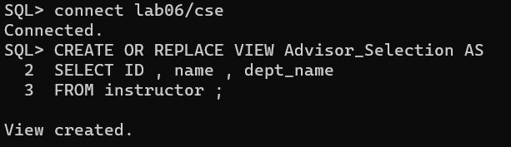
2. Create another view named Student_Count using Advisor_Selection and advisor to show the name of the instructor and the number students assigned under them.
CREATE OR REPLACE VIEW Student_Count AS
SELECT a.name ,COUNT(d.s_id)as st_count
FROM Advisor_Selection a
Join advisor d ON a.id=d.i_id
group by a.name;
GROUP BY a.name;

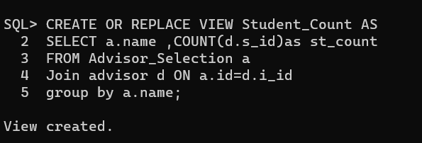
3. Four categories of users have been identified in the database:
(a) Students should be able to view information regarding advisors and courses.
CREATE ROLE std_role;
GRANT SELECT ON advisor TO std_role;
GRANT SELECT ON course TO std_role;

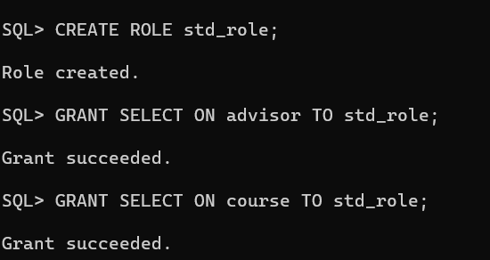

(b) Course teachers should be able to view information about the students and courses.
CREATE ROLE t_role;
GRANT SELECT ON student TO t_role;
GRANT SELECT ON course TO t_role;

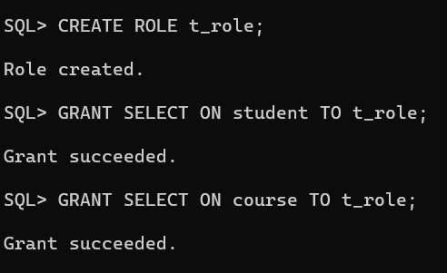
(c) Head of the Departments should have all the privileges that a course teacher has. Additionally, s/he should be able to add new instructors.

CREATE ROLE hod_role;
GRANT t_role TO hod_role;
GRANT SELECT,INSERT ON instructor TO hod_role;

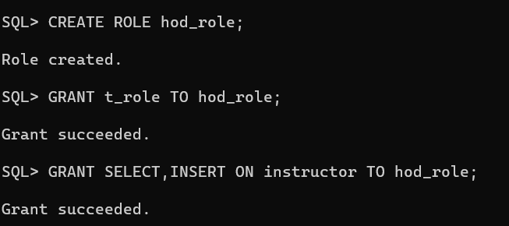
(d) Administrator should be able to see information about department and instructors. They should also be able to update the department budget.

CREATE ROLE admin_role;
Grant select ON department TO admin_role;
Grant update(Budget) ON department TO admin_role;
Grant select ON instructor TO admin_role;

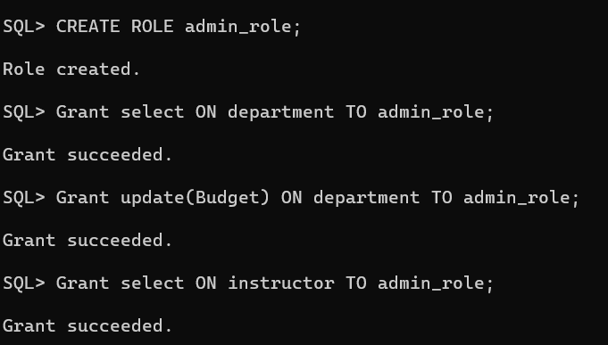
4. Create users under these roles and write relevant SQL queries to demonstrate that the imposed access control works.

drop user stud ;
drop user teach ;
drop user dept ;
drop user admin ;

create user stud identified by s;
create user teach identified by t ;
create user dept identified by d ;
create user admin identified by a ;

grant create session , resource , create tablespace to stud;
grant create session , resource , create tablespace to teach;
grant create session , resource , create tablespace to dept;
grant create session , resource , create tablespace to admin;

grant std_role to stud ;
grant t_role to teach ;
grant hod_role to dept ;
grant admin_role to admin ;
SELECT * FROM Advisor_Selection;
SELECT * FROM student;
SELECT * FROM course;

INSERT INTO instructor (ID, name, dept_name, salary) VALUES ('12', 'Farhan', 'Comp. Sci.', 90000);
SELECT * FROM instructor;

UPDATE department SET budget = 130000 WHERE dept_name = 'Comp. Sci.';

SELECT * FROM department;
SELECT * FROM instructor;

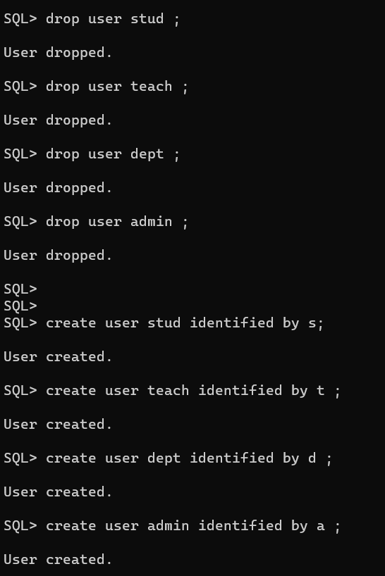
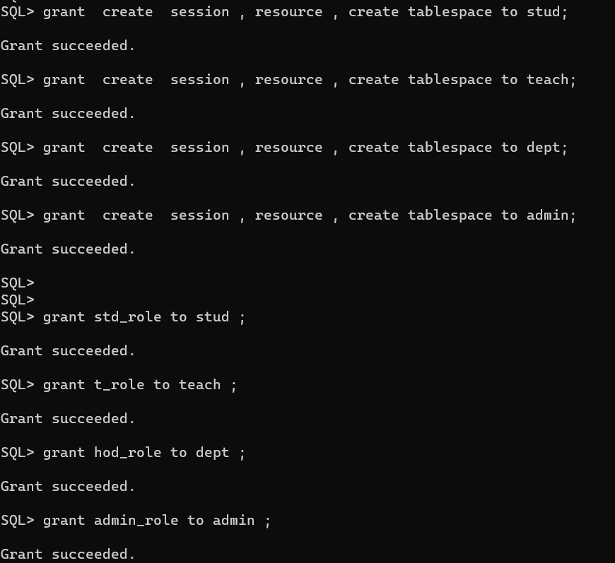

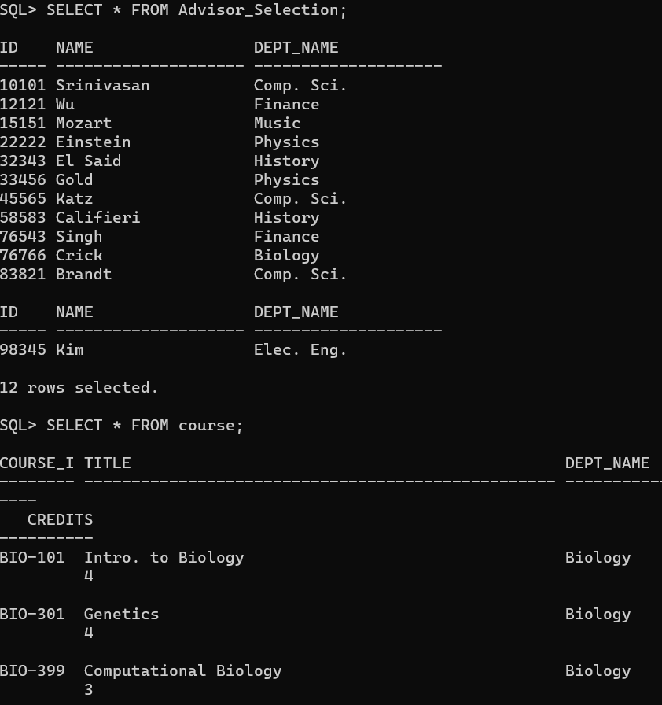
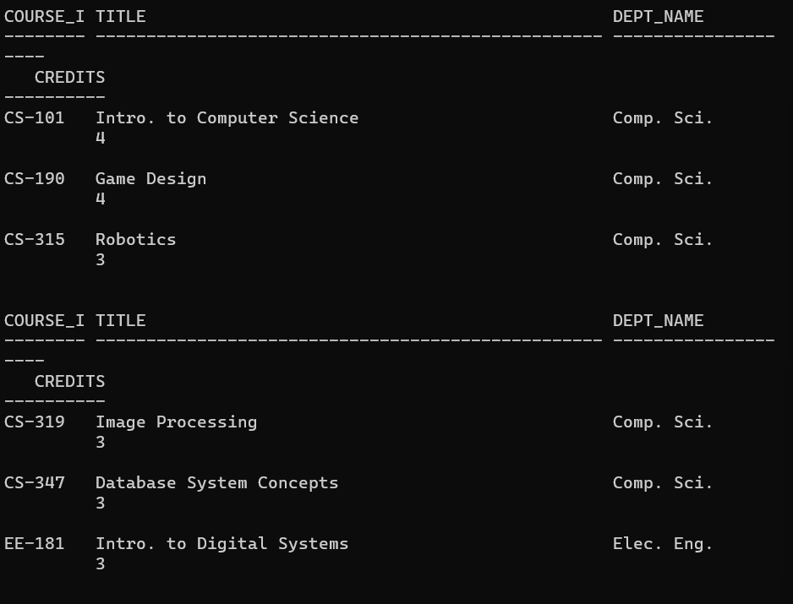
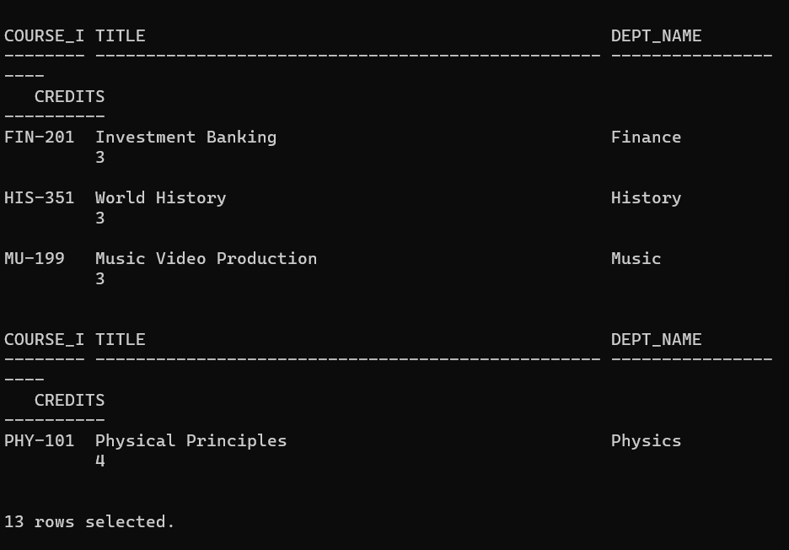
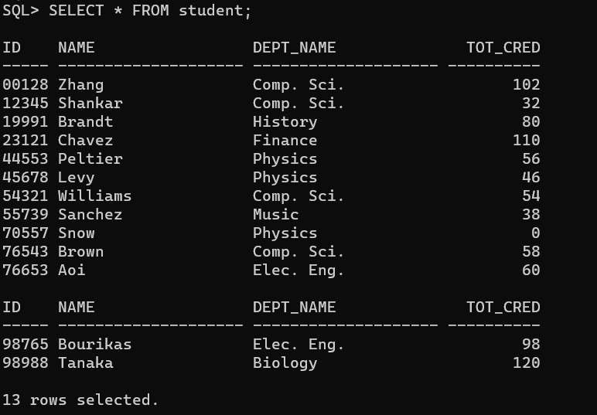
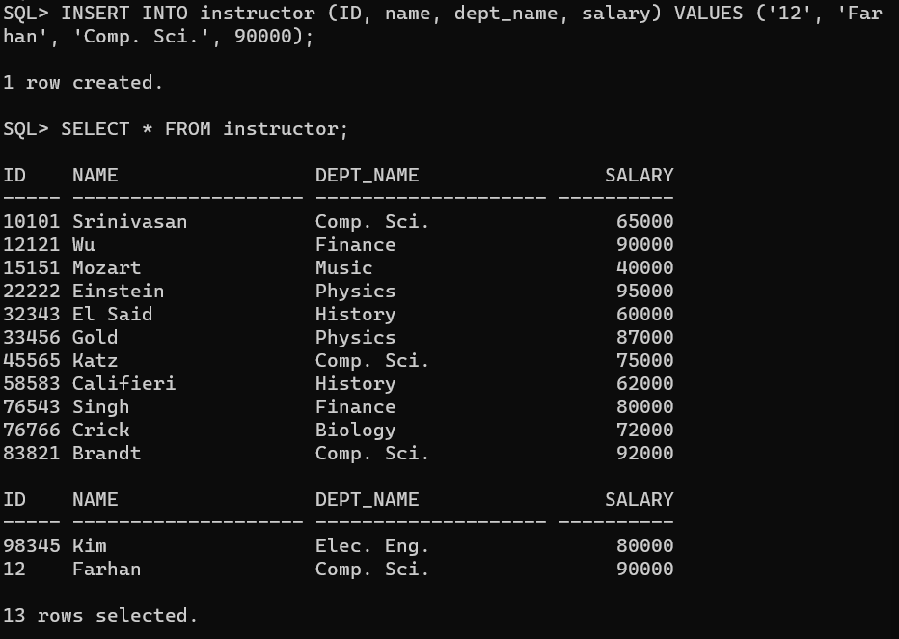
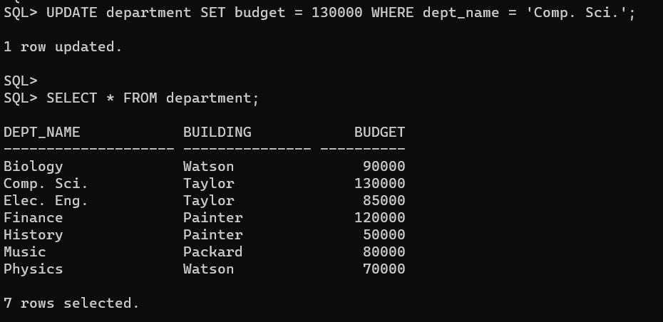
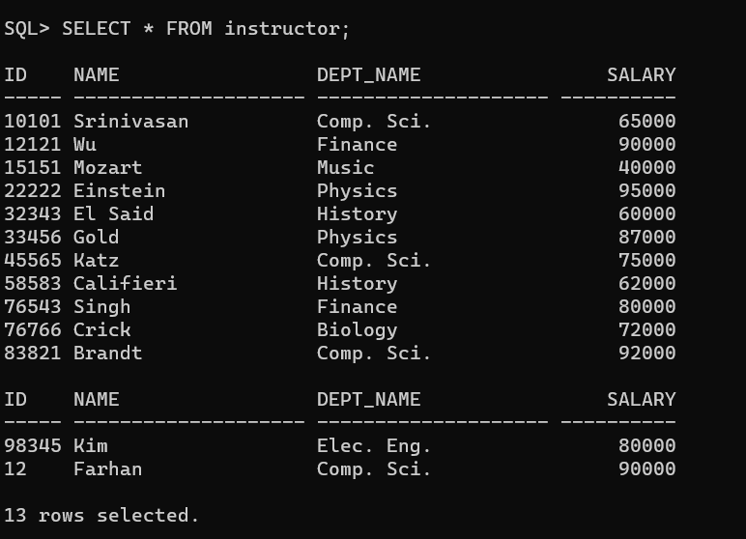
Problems faced :
Syntax Errors: SQL queries must have some strict syntax requirements. Incorrectly worded queries might result in syntax problems and as a beginner I did struggle to get the syntax properly.
Understanding Database Structure: as I was not so familiar with the structure of the database I am working with, it might be difficult to determine which tables exist, what columns they include, and how they relate to one another.
Table Creation: Creating tables with the right structure and data types were a bit tricky. Defining primary keys, Foreign keys, and constraints correctly is essential.
Finding out and Declaring Foreign seems hard to me. And command line of declaring foreign key is also.
Connect Table : to connect multiple table command is a bit difficult to me.

